Blake Topham, Erol Anil, Nathan Tai

Movie Database Project

RAD Project- Team Elite

# Contents

Contents i

Figures v

Tables v

Source Control Screenshot 1

Analysis Report 1

Introduction: 1

CITE business rules for software development: 1

CITE Managed Services Quality Assurance: 2

Full-cycle QA Testing. 2

Document and Code Reviews 2

Defect Tracking 2

Configuration Management 2

Process Monitoring 2

Risk Management 2

Acme Entertainment Pty Ltd development requirements: 3

Create a working prototype of a movie database and webpage frontend. 3

Create a multi-platform report to determine if we should use an adaptive or responsive approach for multi-platform support. 3

Implement the chosen approach into the prototype. 3

Team Meeting 4

Client Meeting 1 5

Consistency Validation Report 6

Adaptive Design 2

Description 2

Advantages 2

Disadvantages 2

Responsive Design 2

Description 2

Advantages 2

Disadvantages 2

Project Selection 3

Navigation Chart 3

Software Testing Plan 4

Introduction 4

Scope 4

In Scope 4

Out of Scope 4

Quality Objective 5

Objectives 5

CITE MS QA Standards 5

Roles and Responsibilities 6

Scrum Master 6

Configuration Manager 6

Developer 6

Test Methodology 6

Overview 6

Test Levels 6

Test Tables 7

Screenshots 9

Bug Triage 1 14

Suspension Criteria and Resumption Requirements 15

Test Completeness 15

Test Deliverables 15

Resource and Environment Needs 16

Testing Tools 16

Test Environment 16

Glossary 16

Source Control Snapshot 17

GitHub Repository 17

Performance Report 18

Definition 18

Goal 18

Assumptions 18

Process Description 18

Optimizer Tools 20

PHPLOC 20

Data Need Analysis 21

Collecting 21

Aggregating 21

Visualizing 21

Interpreting 22

Analyzing 22

Reporting 22

Performance of Results 23

Performance of Top 10 Movies 23

Performance of Home Page 24

Software Review Plan 25

Current Architecture 25

Software Quality Issues 26

Modularity 26

Portability 26

Efficiency 26

Extensibility 26

Readability 26

Proposed Improvements 26

Suggestions/Recommendations (Optional) 26

Testing 27

Scope 27

Test Table 28

Screenshots 30

Bug Triage 2 40

Team Meeting 2 41

Client Meeting 2 43

Source Control Snapshot 44

Optimization Report 45

Description 45

Need for Optimization 45

Case Studies 45

Best Practices 45

Performance Tuning Steps Followed 46

Performance Tuning Steps Followed 47

Previous Observations 48

Network Analytics 49

Memory Status 50

Security 51

Warnings / Error Logging 52

Current Performance Extract Report 53

Updated Software Testing Plan 54

Reflections 54

Testing Overview 54

Scope 54

Test Table 55

Screenshots 57

Team Meeting 3 70

Client Meeting 3 72

Bug Triage 3 73

# Figures

Figure 1- GitHub Screenshot 6

Figure 2- GANTT Chart 2

Figure 3- GANTT Chart (continued) 2

Figure 4- Test Case 1 failed 19

Figure 5- Name search 19

Figure 6- Name, Genre 19

Figure 7-Name, Genre, Rating 20

Figure 8- Name, Genre, Rating, Year 20

Figure 9- Top ten 21

Figure 10- Runs on PC 21

Figure 11- Runs on iPad 22

Figure 12- Runs on Galaxy S9 23

Figure 13- GitHub repository 27

Figure 14- GANTT chart sprint two 27

Figure 15- Search by name 39

Figure 16- Name, Genre 40

Figure 17-Name, Genre, Rating 41

Figure 18- Name, Genre, Rating, Year 42

Figure 19- Top ten 43

Figure 20- Runs on PC 43

Figure 21- Runs on iPad 44

Figure 22- Runs on S5 45

Figure 23- User unsubscribes, database not yet reflected 46

Figure 24- User unsubscribes, admin email 47

Figure 25- Admin unsubscribes user 48

Figure 26- GitHub screenshot 53

Figure 27- GANTT chart 54

Figure 28- Search by name 67

Figure 29- Name, Genre 68

Figure 30-Name, Genre, Rating 69

Figure 31- Name, Genre, Rating, Year 70

Figure 32- Top ten 71

Figure 33- Runs on PC 71

Figure 34- Runs on iPad 72

Figure 35- Runs on S5 73

Figure 36- User unsubscribes, database not yet reflected 74

Figure 37- User unsubscribes, admin email 75

Figure 38- Admin unsubscribes user 76

Figure 39- Admin logs in 77

Figure 40- User leaves a score 78

Figure 41- Ten highest-rated 79

Figure 42- Search by name 91

Figure 43- Name, Genre 92

Figure 44-Name, Genre, Rating 93

Figure 45- Name, Genre, Rating, Year 94

Figure 46- Top ten 95

Figure 47- Runs on PC 95

Figure 48- Runs on iPad 96

Figure 49- Runs on S5 97

Figure 50- User unsubscribes, database not yet reflected 98

Figure 51- User unsubscribes, admin email 99

Figure 52- Admin unsubscribes user 100

Figure 53- Admin logs in 101

Figure 54- User leaves a score 102

Figure 55- Ten highest-rated 103

# Tables

Table 1- Bug Report 27/05/2021 14

Table 2- Timeline of Test Deliverables 15

Sprint One

Handover

# Final Test Plan

## Test Table

|  |  |  |  |  |  |  |  |  |
| --- | --- | --- | --- | --- | --- | --- | --- | --- |
| Test Report H1 T1 | | | | | | | | |
| Project Name: RAD Sprint Three | | | Test Type: White box | | | | | |
| Description: Movie Search Application | | | Date: 20/06/2021 | | | | | |
| Developer(s): Blake Topham, Erol Anil, Nathan Tai | | | Tester: Blake Topham | | | | | |
| Test Case # | Test Case Name | Test Steps | | Test Data | | Expected Results | Evidence | Pass? |
| 1 | Search by Name | Enter search terms | | Search term | | Matching results displayed | Figure 27 |  |
| 2 | Search by Name, Genre | Enter search terms | | Search term | | Matching results displayed | Figure 28 |  |
| 3 | Search by Name, Genre, Rating | Enter search terms | | Search term | | Matching results displayed | Figure 29 |  |
| 4 | Search by Name, Genre, Rating, Year | Enter search terms | | Search term | | Matching results displayed | Figure 30 |  |
| 5 | Top Ten Movies | Click “10 Most Searched” button | | 10 movies with highest search count | | 10 movies with highest search count displayed | Figure 31 |  |
| 6 | Runs on: Desktop PC | Run page in desktop browser | | Page elements | | Page runs | Figure 32 |  |
| 7 | Runs on:  iPad | Run page in device simulation mode | | Page elements | | Page runs | Figure 33 |  |
| 8 | Runs on: Galaxy S5 | Run page in device simulation mode | | Page elements | | Page runs | Figure 34 |  |
| 9 | User subscribes | Enter email and click subscribe | | Email address | | User subscribed, receives newsletter/newsflash | Figure 35 |  |
| 10 | User unsubscribes | Enter email and click unsubscribe | | Email address | | Email sent to Admin account for database removal | Figure 36 |  |
| 11 | Admin removes user | Run admin user unsubscribe command. | | User details(email, etc.) | | User entry set to unsubscribed | Figure 37 |  |
| 12 | Admin login | Enter admin details | | Admin login details | | Admin features enabled | Figure 38 |  |
| 13 | User adds rating | Enter rating as user | | Score | | Rating added to database | Figure 39 |  |
| 14 | Rating auto-updates on page | View any movie search results | | Score | | Rating auto-updates on page | Figure 40 |  |
| Test Completeness Criteria Achieved:  1. All test cases carried out successfully  2. All bugs fixed | | | | | Suspension Criteria Met:  1. Vital functionality broken  2. Error directly prevents further testing  3. Errors too many or too often  4. Error makes further testing redundant | | | |
| Testing Complete | | | | | Testing Suspended | | | |

### Screenshots

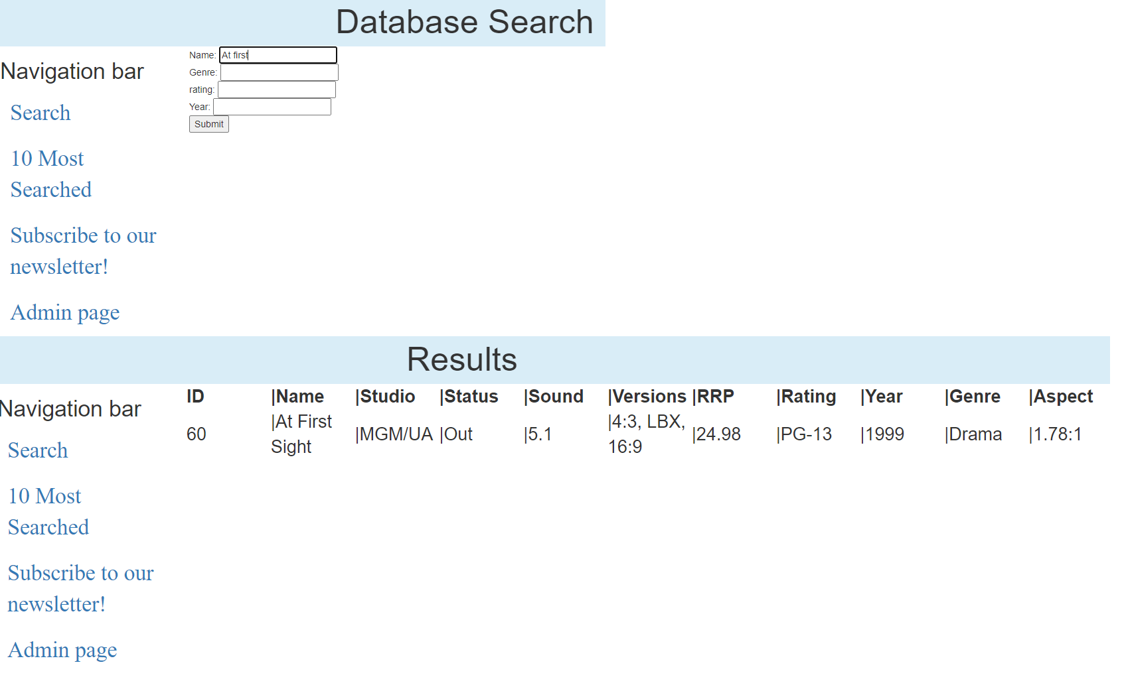

Figure 42- Search by name

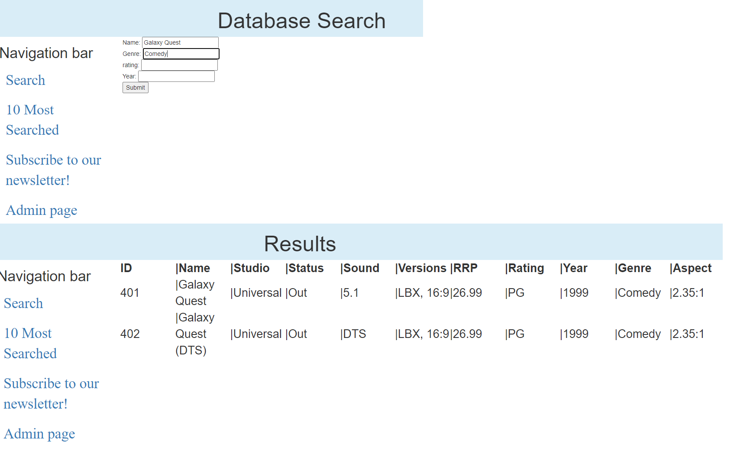

Figure 43- Name, Genre

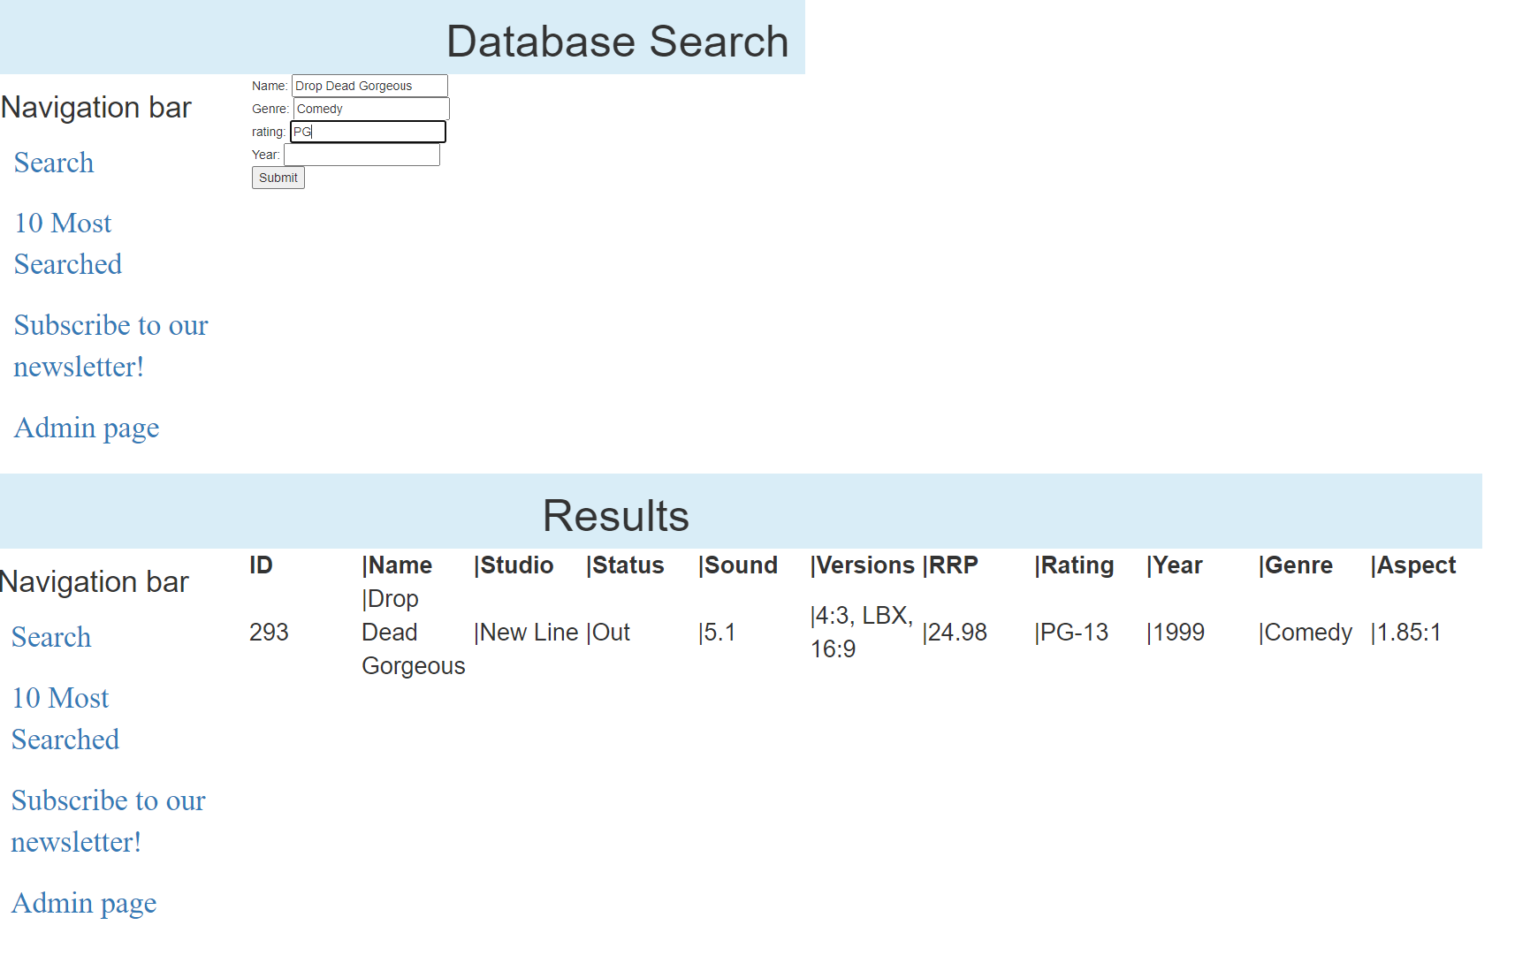

Figure 44-Name, Genre, Rating

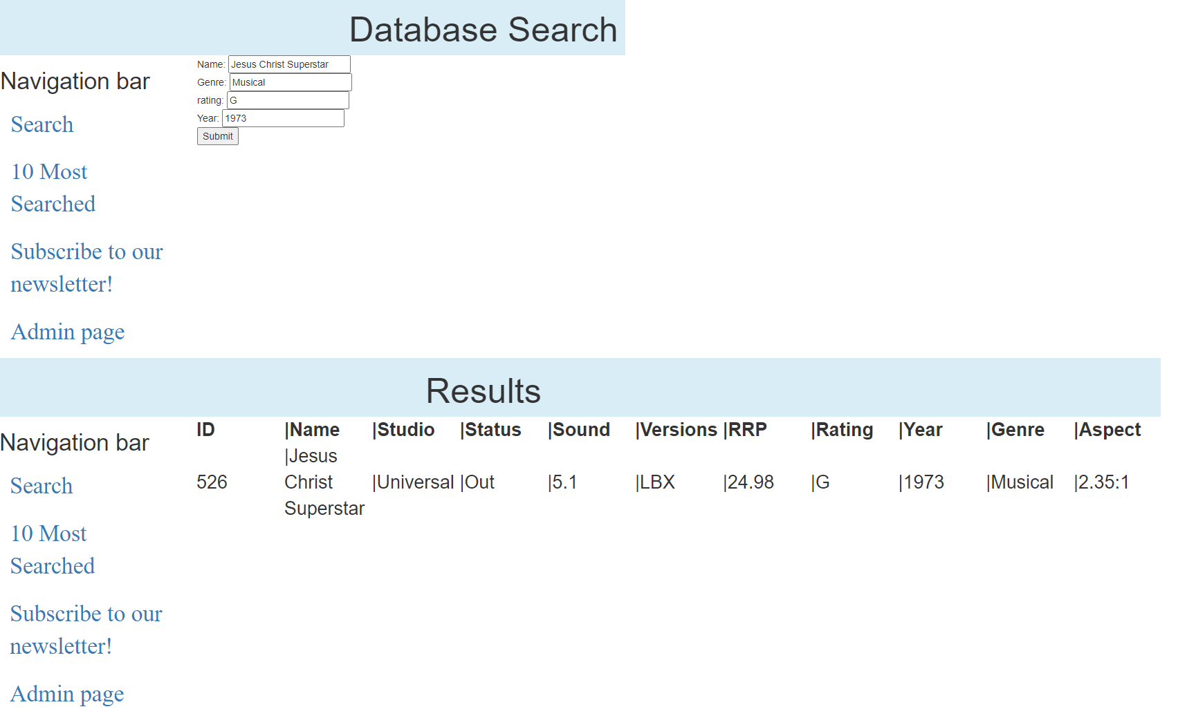

Figure 45- Name, Genre, Rating, Year

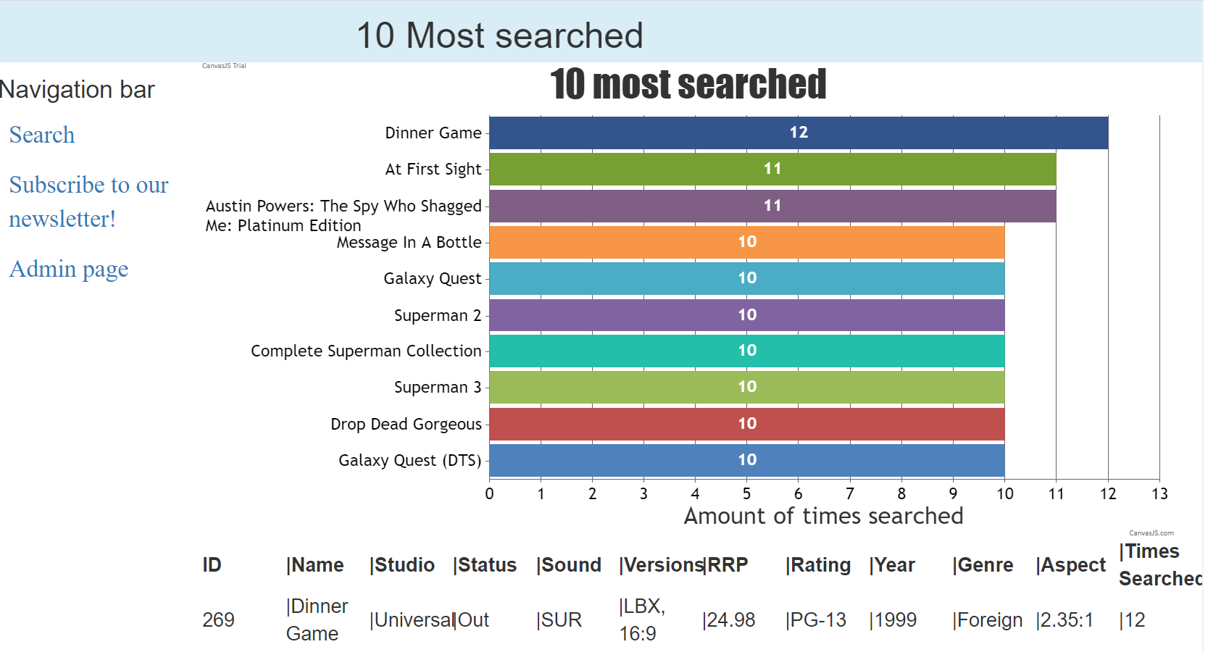

Figure 46- Top ten



Figure 47- Runs on PC

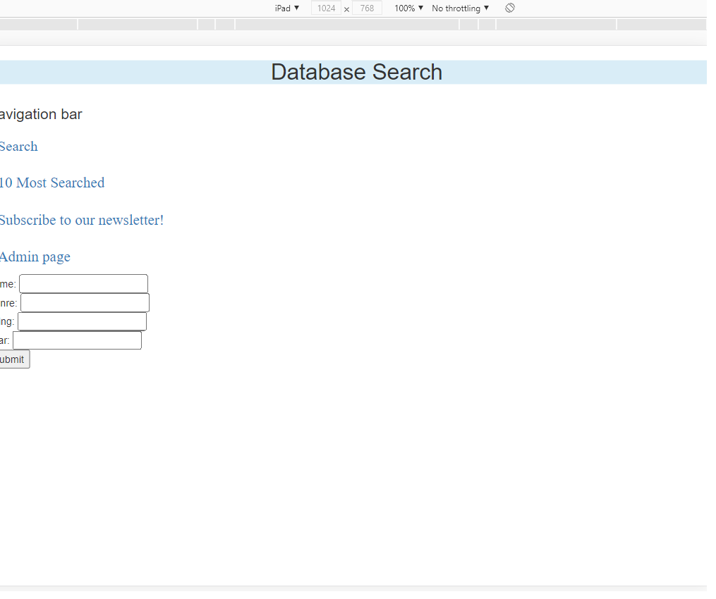

Figure 48- Runs on iPad

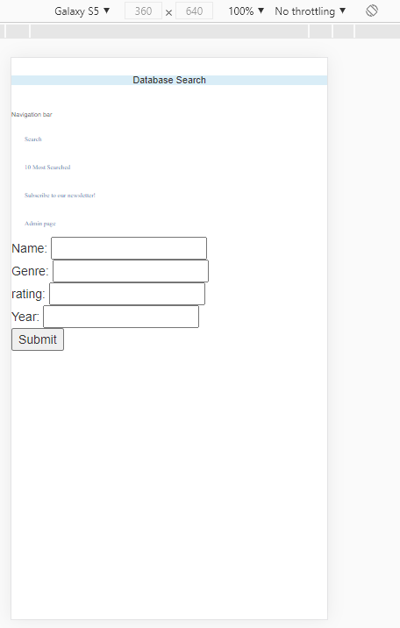

Figure 49- Runs on S5

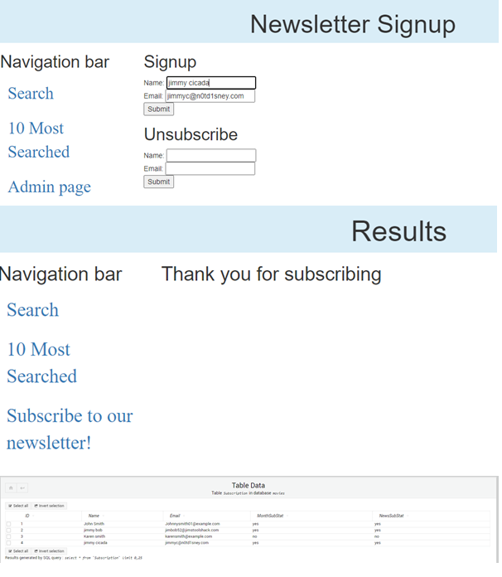

Figure 50- User unsubscribes, database not yet reflected

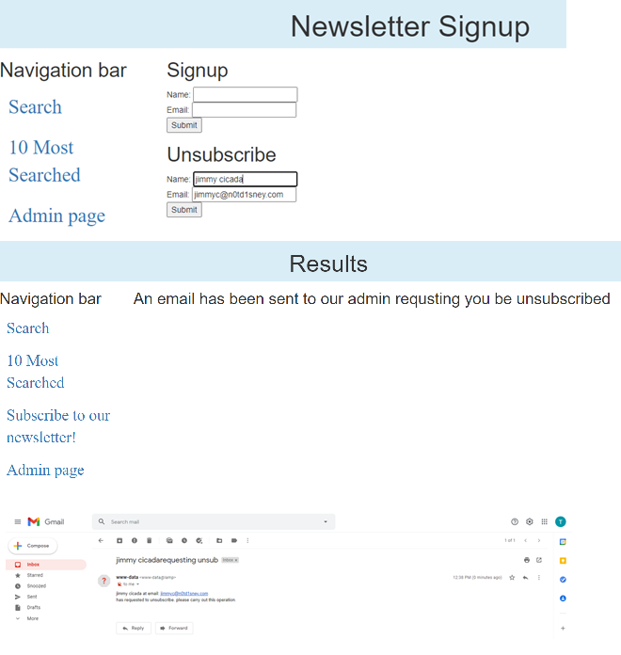

Figure 51- User unsubscribes, admin email

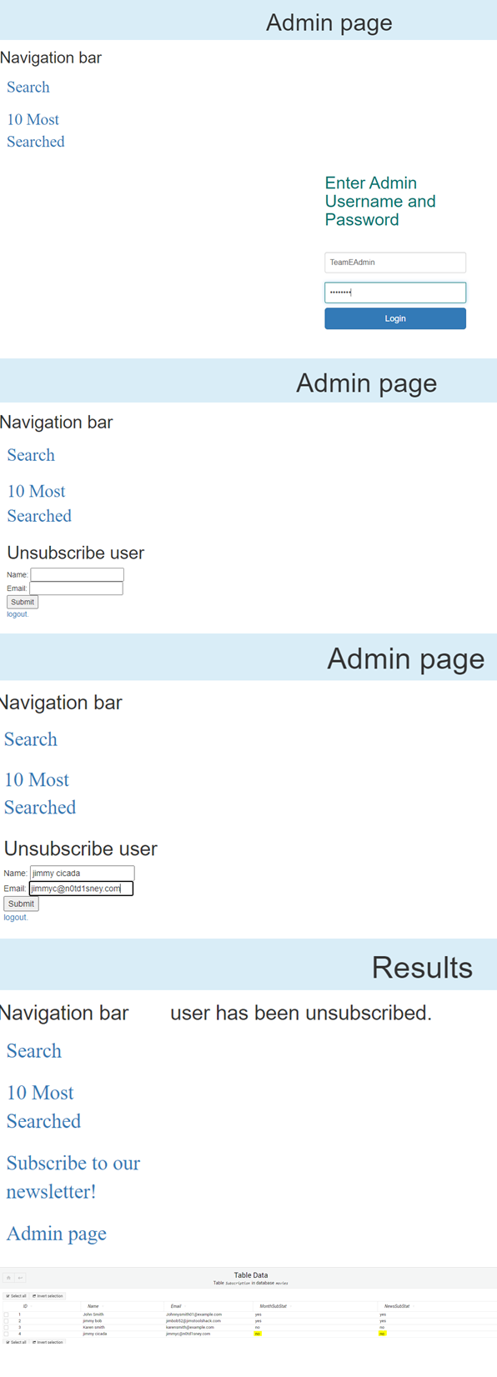

Figure 52- Admin unsubscribes user

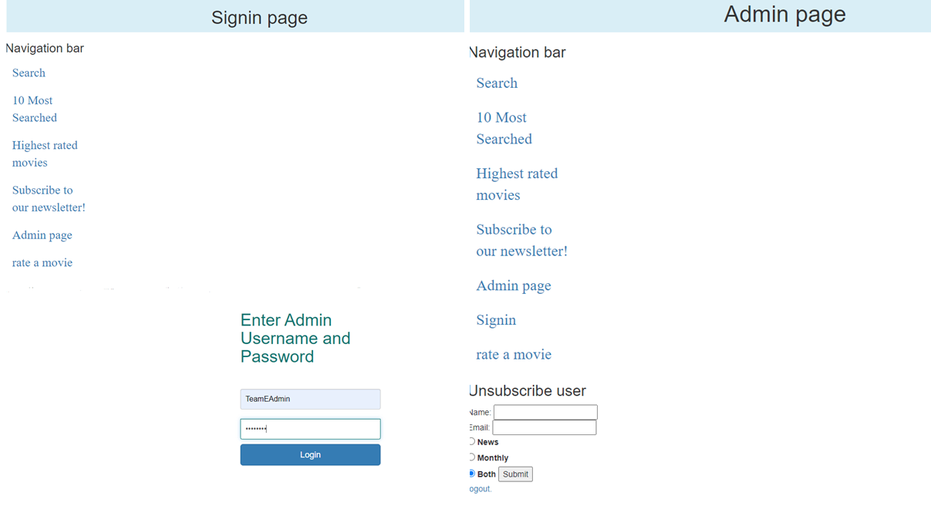

Figure 53- Admin logs in

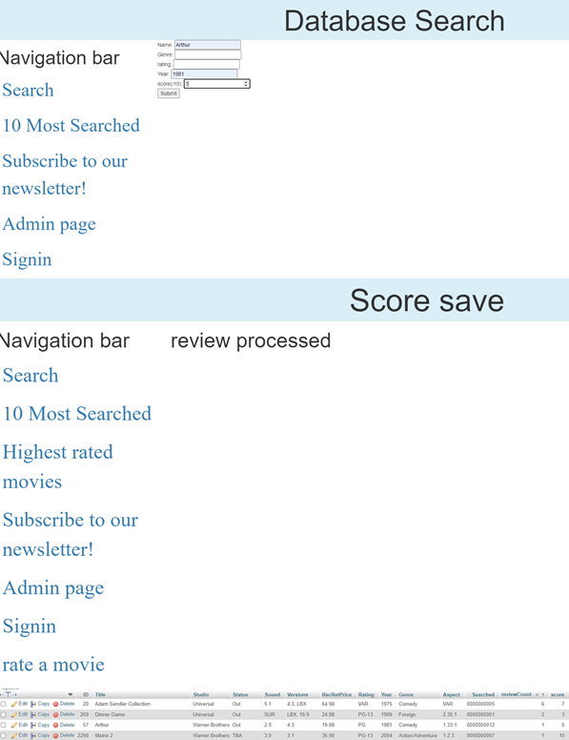

Figure 54- User leaves a score

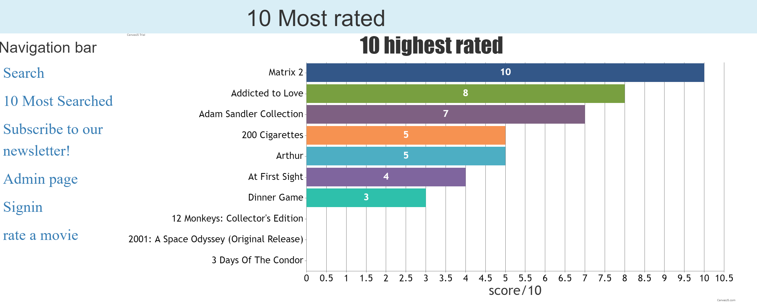

Figure 55- Ten highest-rated

### Team Meeting 4

#### Meeting Minutes

17/06/2021

Present: Blake Topham, Erol Anil, Nathan Tai

Next meeting: 24/06/2021, 9:00AM, Murdoch Campus

**BLAKE: Testing**

* Test plan
* Testing
* WACG report

**EROL: Configuration**

**Source Control Snapshot**

* Update GitHub Kanban
* Create screenshots, add to master document

**General Version Control**

* Manage repositories (GitHub)

**NATHAN: Software Review/Documentation**

**Software Review Plan**

* Summarize current architecture
* Suggest possible areas of enhancement

**Master document control**

* Collate files into master document
* Proofreading
* Formatting

### Client Meeting 4

#### Meeting Minutes

17/06/2021

Present: Client, Blake Topham, Erol Anil, Nathan Tai

Next meeting: 24/06/2021, 9:30AM, Murdoch Campus

**1. Software Review**

* Review application against WACG standards and report findings.

**2. Final checks**

* Finalize code and documentation

### Bug Triage 4

#### Meeting Minutes

17/06/2021

Present: Blake Topham, Erol Anil, Nathan Tai

Next meeting: 24/06/2021, 9:00AM, Murdoch Campus

**1. Bug Report**

No bugs detected.

**2. Triage (Bug Priority)**

N/A

|  |  |  |  |  |  |
| --- | --- | --- | --- | --- | --- |
| **#ID** | **DESCRIPTION** | **SEVERITY** | **FREQUENCY** | **RISK** | **PRIORITY** |
| N/A | N/A | N/A | N/A | N/A | N/A |